**Karen cabrera**

**BASES DE DATOS 2 (ORACLE)**

**Parcial n#3**

**1.**

CREATE OR REPLACE TRIGGER T_ActAproba

AFTER INSERT ON Prestamos

FOR EACH ROW

BEGIN

INSERT INTO auditoria

Values

(SAditroia.NEXTVAL, ’Prestamos’, :New.ID_Cliente, :New.ID_Tipo, :OLD.M_aprobado, :New.M_pagado, :OLD.M_aprobado-:New.M_pagado,user,sysdate);

END T_ActAproba;

/

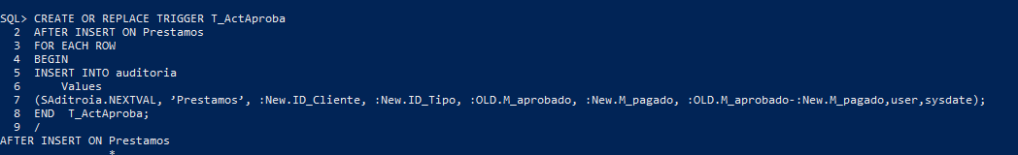

**2.** CREATE OR REPLACE TRIGGER T_cmonto

AFTER INSERT ON Prestamos

UPDATE Sucursal_Prestamo

SET montopres = montopres+ :New. M_aprobado Where tipoprestamo=p_IDtip AND cod_sucursal=p_codSuc;

IF SQL%ROWCOUNT=0 THEN

INSERT INTO Sucursal_Prestamo

Values(:New.ID_Tipo,:New. cod_sucursal,:New.M_aprobado);

END T_cmonto;

**/**

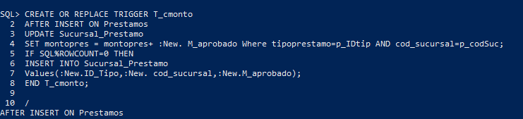

**3.** CREATE OR REPLACE TRIGGER AUD_TRANSAC

BEFORE UPDATE OR DELETE OR INSERT ON TRAN_PAGOS

FOR EACH ROW

DECLARE

v_TipoCambio CHAR(1);

BEGIN

IF UPDATING THEN

v_TipoCambio := 'U';

INSERT INTO AUDITORIA_t,

VALUES (trig_transac.nextval, v_tipoCambio, :NEW.cod_sucursal, :NEW.id_cliente, :NEW.id_tipo, :new.monto_pago, user, sysdate);

ELSIF INSERTING THEN

v_TipoCambio := 'I';

INSERT INTO AUDITORIA_t

VALUES (trig_transac.nextval, v_tipoCambio, :NEW.cod_sucursal, :NEW.id_cliente, :NEW.id_tipo, :new.monto_pago, user, sysdate);

ELSIF DELETING THEN

v_TipoCambio := 'D';

INSERT INTO AUDITORIA_t

VALUES (trig_transac.nextval, v_tipoCambio, :NEW.cod_sucursal, :NEW.id_cliente, :NEW.id_tipo, :new.monto_pago, user, sysdate);

END IF;

END TRIGGER AUD_TRANSAC;

/

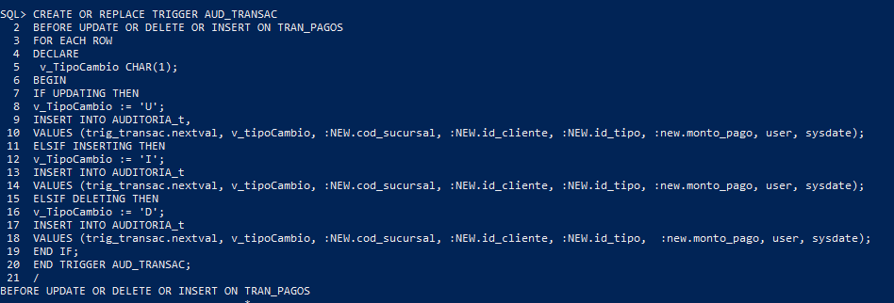

**4.** CREATE OR REPLACE TRIGGER T_Afecta

AFTER UPDATE OR DELETE OR INSERT ON Prestamos

FOR EACH ROW

BEGIN

UPDATE Sucursal_Prestamo

SET montopres = montopres+ :New. M_aprobado Where tipoprestamo=p_IDtip AND cod_sucursal=p_codSuc;

END T_Afecta;

/

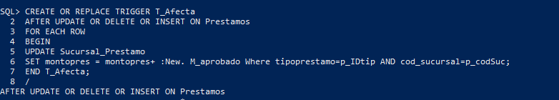

**5.**

create view PRESTAMO_SUCURSAL as select s.Nombre_sucursal,tp.tipo,sp.monto_prestamo from SUCURSAL s join SUCURSAL_PRESTAMO sp

on s.Cod_sucursal = sp.cod_sucursal join TIPO_PRESTAMO tp on tp.ID_tipo = sp.ID_tipo;

